**Huda Husain Petkar**

**M. Sc DS AI || L017 || ADBMS**

**Practical - 6**

**Date: 07.02.25**

**Topic: Replication in MongoDB**

1. In C Drive create a folder “data”
2. In the data folder create 3 folders
3. Primary folder
4. Secondary1 - First Secondary folder
5. Secondary2 - Second Secondary folder
6. Open Windows cmd / Powershell
7. Write the foll cmd

mongod --port=2717 --dbpath="C:\data\primary" --replSet="test-replica-set"

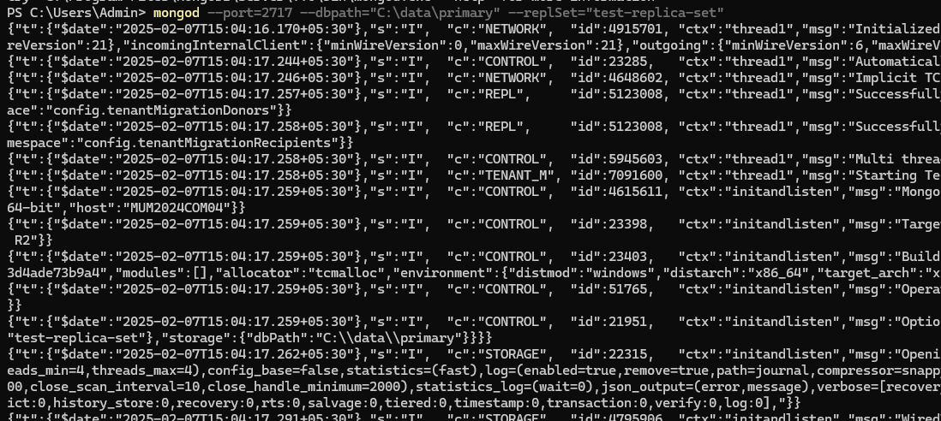

1. Open a new instance & write the foll cmd

mongod --port=2727 --dbpath="C:\data\secondary1" --replSet="test-replica-set"

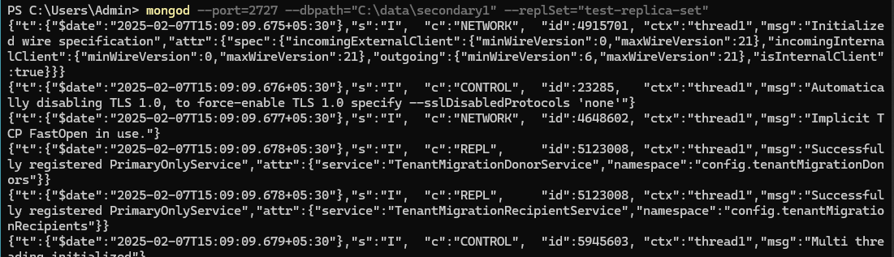

1. Then create another instance and run the foll cmd

mongod --port=2737 --dbpath="C:\data\secondary2" --replSet="test-replica-set"

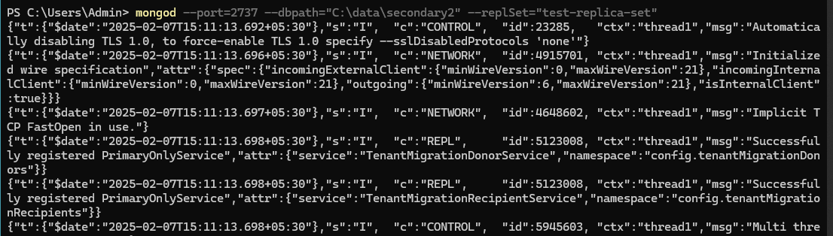

1. Create a new instance and write the foll cmd

mongosh --host="localhost:2717"

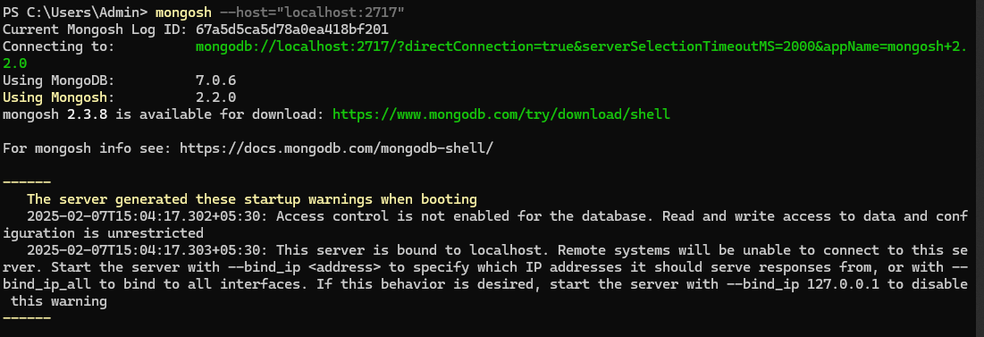

1. rs.initiate()

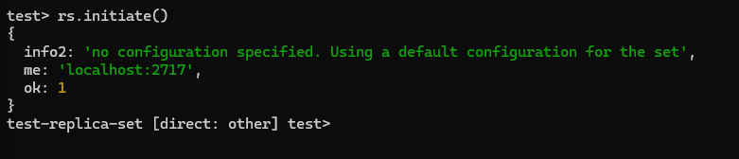

1. rs.add({host:"localhost:2727"});

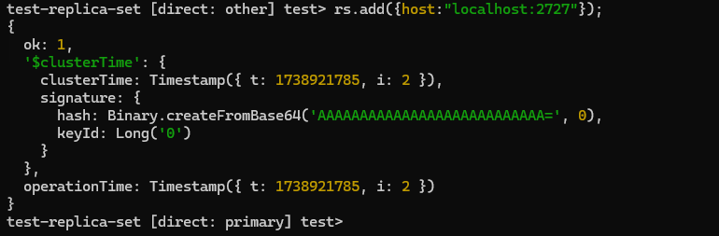

1. rs.add({host:"localhost:2737"});

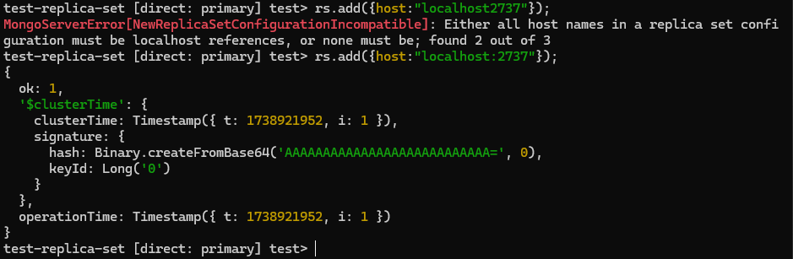

1. rs.status()

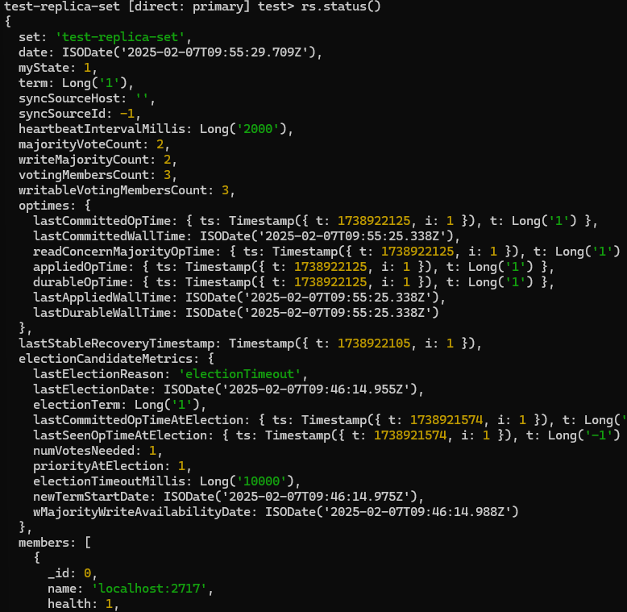

1. Create a new instance

mongosh --host="localhost:2727"

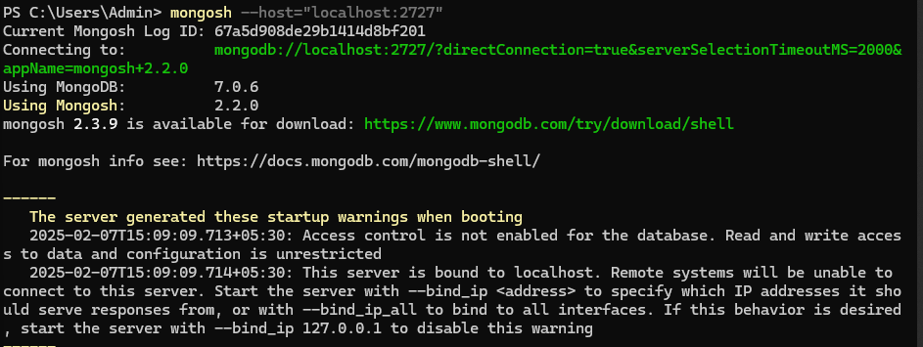

1. Create a new instance

mongosh --host="localhost:2737"

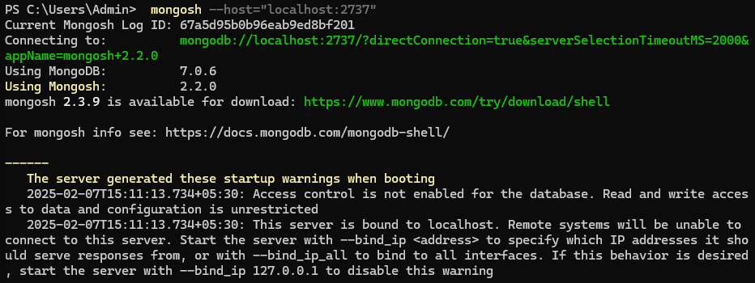

1. Open the instance with the primary server

Run the cmd

show dbs

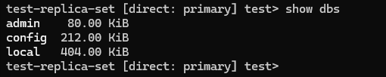

The same databases should be reflecting in our secondary servers

Secondary1:

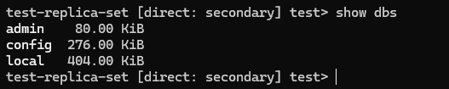

Secondary2:

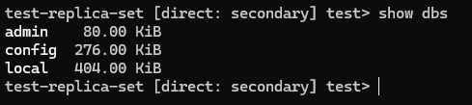

1. Open the primary server instance then create database

use practical



1. Insert some records

db.users.insertMany([ { name: "Huda", roll_no: 17, age: 21 }, { name: "Shifa", roll_no: 18, age: 22 }, { name: "Tasmiya", roll_no: 21, age: 23, address: "Mumbai" }, { name: "Samiya", roll_no: 12, address: "Delhi" } ]);

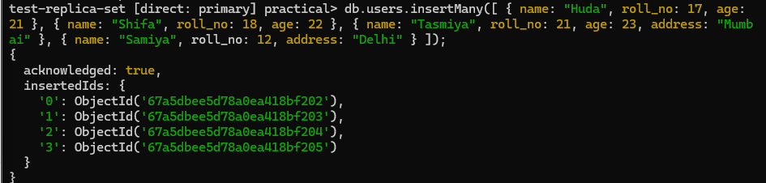

1. Reading the entries

db.users.find()

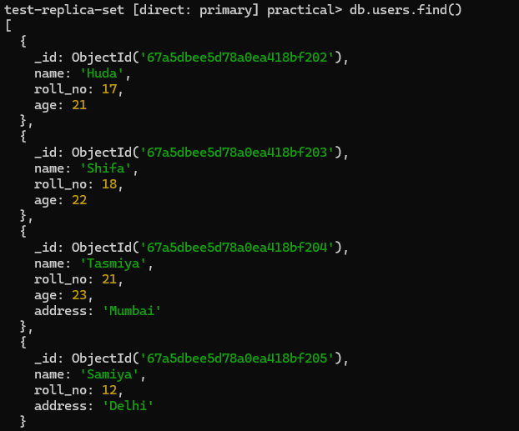

1. Now switch to your secondary server

use practical

Now try to read the data

db.users.find()

First Secondary server:



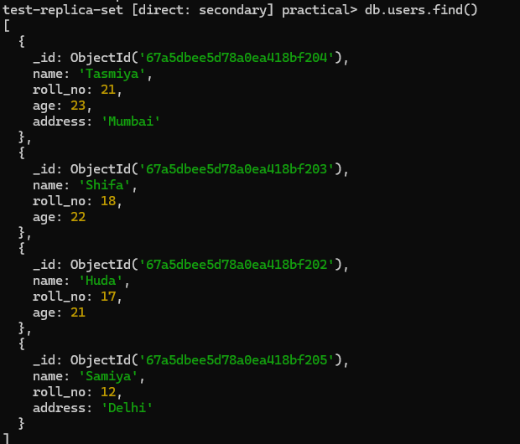

Second Secondary server:



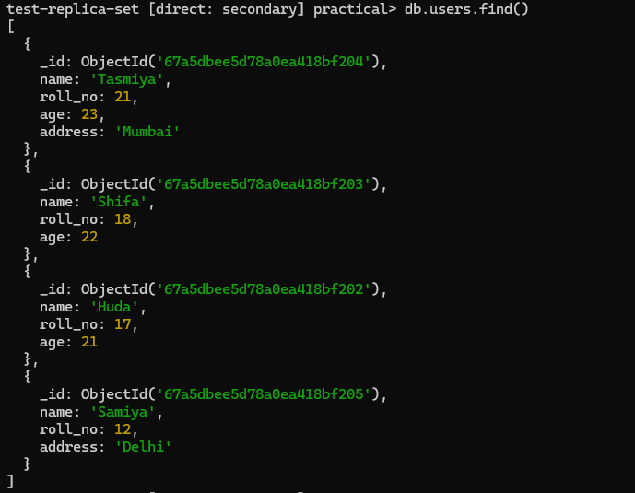

1. Performing more CRUD Operations
2. Insert a single record

db.users.insertOne({ name: "Nina", roll_no: 19, age: 20 });

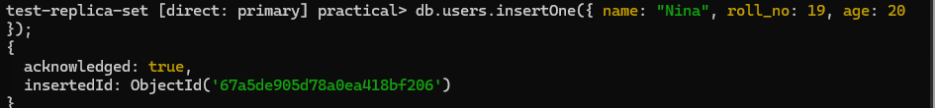

1. Insert Multiple records

db.users.insertMany([{ name: "Sana", roll_no: 20, age: 22 },{ name: "Emad", roll_no: 21, age: 24 }]);

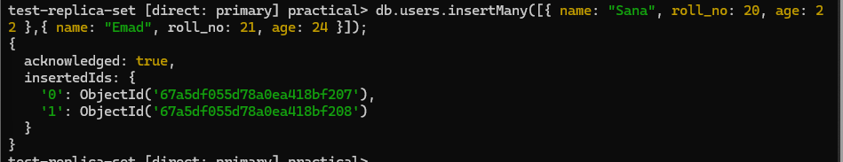

1. Find record where name = “Huda”

db.users.find({ name: "Huda" }).pretty();

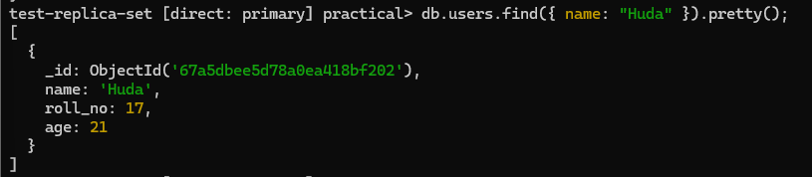

1. Update a document

db.users.updateOne( { name: "Shifa" }, { $set: { age: 23 } });

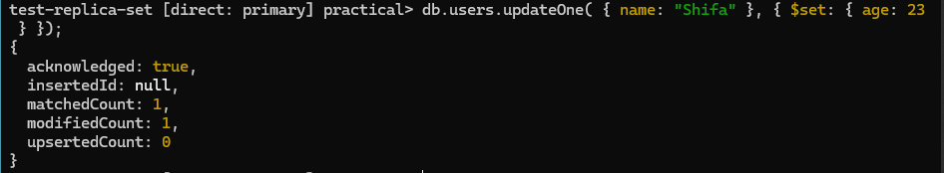

1. Update multiple documents

db.users.updateMany( { age: { $lt: 23 } }, { $set: { status: "young" } });

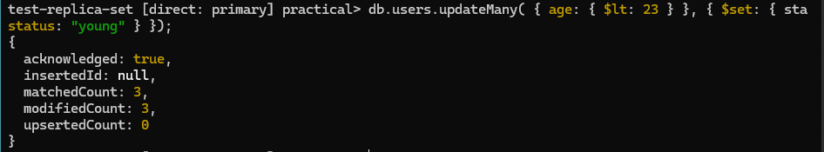

All the changes we made are reflected in the secondary server

First secondary server

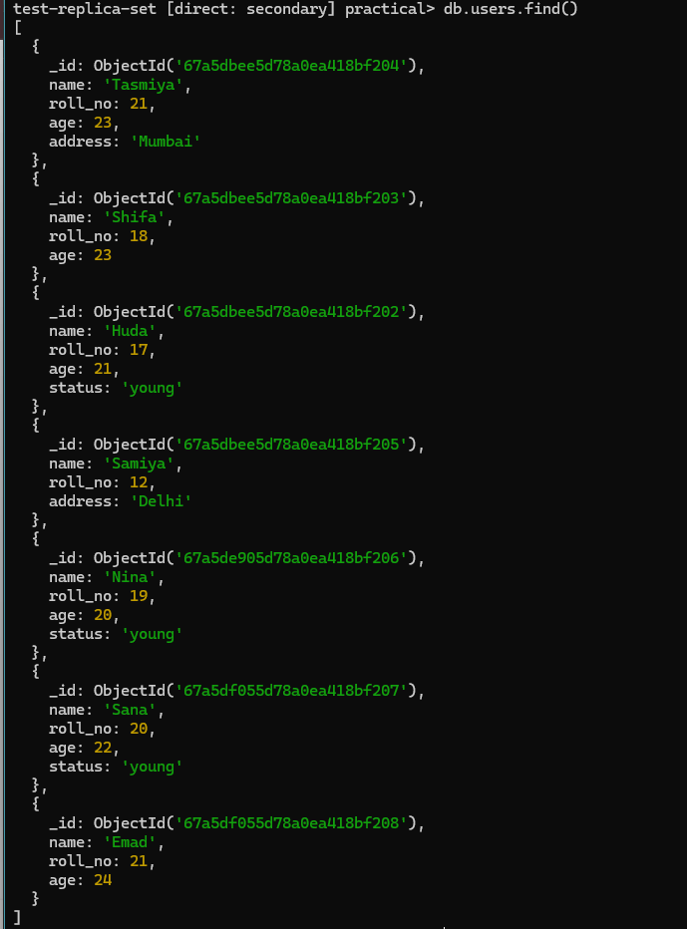

Second Secondary server

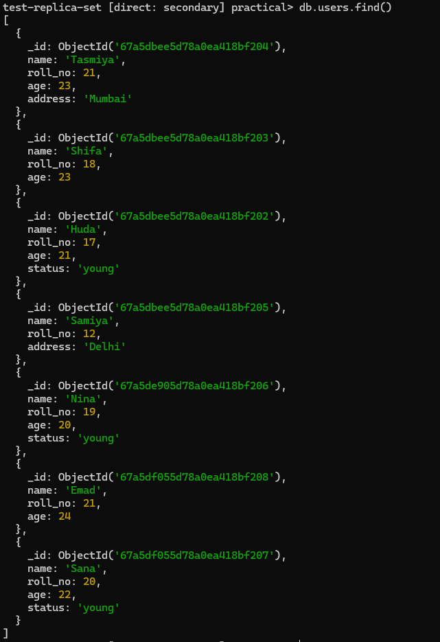

1. Delete a single record

db.users.deleteOne({ name: "Samiya" });



1. Delete multiple records

db.users.deleteMany({ age: { $gt: 22 } });



Changes successfully reflected in the secondary servers

